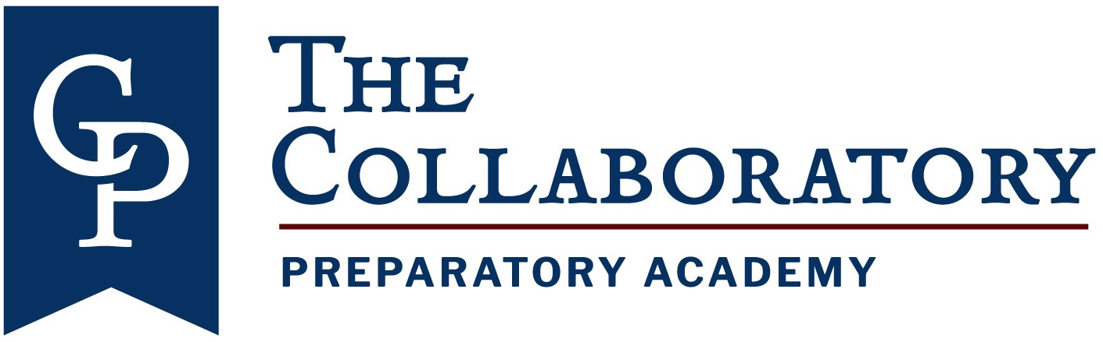
Board of Directors
Meeting
April 5,
2022

The Collaboratory Preparatory Academy Board Meeting April 5, 2022
Attendees: Trey Traviesa, Dr. Kevin Scott, Darren Curtis, Jordan Snyder, Cimone Sommers, LaShaniqua Kelly

Agenda
- Call to Order
- Additions or Corrections
- Public Comments on Agenda Items
- Approval of Minutes, December 7, 2021 (Attachment A, Board to vote)
- Reports and Discussion
    - Academic Update (Attachment B)
    - Discussion of ARP Grant Funds – to be discussed at next board meeting TBD
- New Business
- Questions/Comment
Adjourn
Attendees: Trey Traviesa, Dr. Kevin Scott, Darren Curtis, Jordan Snyder, Cimone Sommers, LaShaniqua Kelly
AGENDA
- Call to Order- 1:31pm
- Additions or Corrections- none
- Public comments on agenda items- none
- Approval of minutes, 9/2/21- Kevin motions, Darren seconds, passes unanimously
- Reports and Discussion
  - Welcome new parent representative
  - Academic update (attachment B)- progress monitoring shows scores tracking towards a C
  - Personnel- still actively seeking a 4th grade teacher for the remainder of the school year
  - Teacher salary allocation (attachment C)- Kevin motions, Darren seconds, passes unanimously.
  - Jordan Snyder to remain interim principal- brief summary of Jordan’s educational background to board members
  - Next board meeting- January 18 to discuss ARP grant funds and budget
- New business- none
- Question/comments- none
- Adjourn- Kevin motions, Darren seconds, passes unanimously. Adjourn at 2:04pm

Attachment B
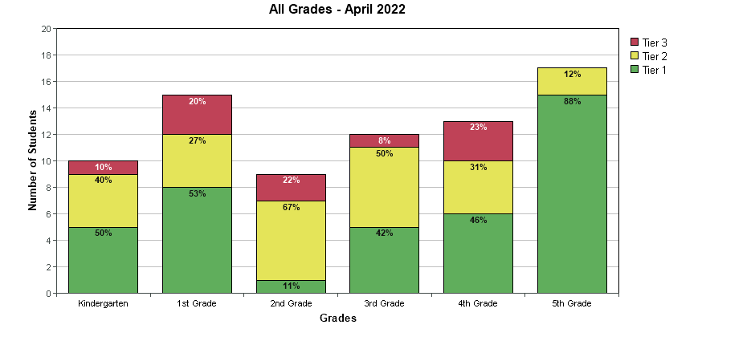
54% of our students tested in tier 1 in reading
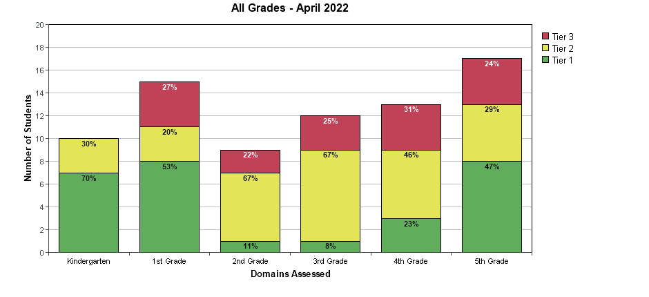
37% of our students are in tier 1 in math
 | 3rd Math | 4th Math | 5th Math | Total Math | 3rd ELA | 4th  ELA | 5th  ELA | TOTAL  ELA | Total  Science | Total grade
Achievement | 5/12 | 9/15 | 13/17 | 19/44  =  59% | 6/13 | 9/14 | 14/17 | 29/44=  64% | 10/17=  59%
Gains | 1/2 | 5/14 | 9/17 | 15/33  =  45% | 1/2 | 8/14 | 10/17 | 19/33=  58% | NA
Gains  (25%) | NA | NA | NA | NA | NA | NA | NA | NA | NA
TOTAL |  |  |  |  |  |  |  |  |  | 54%=B
● If Collaboratory Prep were to take the FSA TODAY, our predicted grade would be a B.

