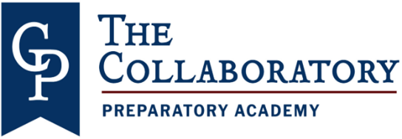
_____________________________________________________________________________________10/30/2023

Dear Parent/Guardian:
All educators in Florida are monitored to ensure they meet certification and training requirements as mandated by law. Per Florida Statute 1012.42, When a teacher is assigned teaching duties out of the field in which the teacher is certified, the parents of all students in the class shall be notified in writing.
In Title I schools, when a child is taught for 4 or more consecutive weeks by a teacher who is non-state certified or state certified, but teaching out-of-field, the LEA must provide written notification to each parent in a timely manner. Information regarding the qualifications of your child’s teacher and/or classroom paraprofessionals may be obtained upon request.
Hillsborough County Public Schools is committed to providing quality instruction for all students and does so by employing the most qualified individuals to teach and support each student in the classroom. The district is assisting our teachers by developing an individual professional development plan to complete the requirements needed to become in field.
All of our teachers are certified to teach, although some of them are currently out-of-field and are working on additional areas of certification. You have the right to know the professional qualifications of the teachers or paraprofessionals who instruct your child. Federal law allows you to ask for certain information about your child’s teacher and requires us to give you this information in a timely manner if you ask for it. If you would like more information, please contact the school at (844) 702-3123.
The table below lists teachers who are currently out-of-field.
Sincerely,

Cassandra D. Smith, M.Ed.
Principal
Teacher | Classes Taught  Assignment(s) | Assignment Start Date | Certification(s) Held | Out-of-Field Area/Classes
Brooks, Erika | ESE | August 10, 2023 | PK-Primary Education | ESE/Gifted
Tucker, Maurice | 4th Grade Teacher | August 10, 2023 | Middle School Social Science | Elementary education K-6

The Collaboratory Preparatory Academy 6406 E. Chelsea St Tampa, FL 33610 844-702-3123

